Assignment #3

Assignment #3 covers Module #4 and #5
Week # June 8th-Jun 14th
Due Date: June 25th

Learning Objectives

- Be able to discuss which risk factors contribute to multifactorial and complex traits and explain to which extent do environmental factors play a role.
- Discuss the role of environment and genetic control of intelligence
- Explain the difference in polyploidy, aneuploidy, monosomy and trisomic conditions.
- Identify variations in chromosome numbers and interpret a karyotype chart

Assignment Description
Purpose of this assignment is to learn how geneticists use karyotypes to identify changes in chromosome numbers. In addition, you will explore how environmental factors can influence the phenotype or trait of an individual. In doing so, you will become aware of how social policies and public policies are shaped by the inheritance of certain traits or vice versa.

Step-by-Step Directions
There are 2 parts- part 1 and part 2.
Part 1-1st- Identify the number of chromosomes for each karyotype. 2nd- Identify if male or female. 3rd. Identify the type of disorder.
Part 2- You are to complete the 3 essays. There are no right or wrong answers and you will provide your thoughts for each question. However, for full credit make sure you focus on the topic or subject matter throughout the essay and write between 150-200 words.

Part 1. Predicting a genetic disorder and identifying a karyotype.
You will analyze the following karyotypes and identify the genetic disorder. Write the # of chromosomes, identify if male or female and type of disorder or normal. Find answers in your textbook or powerpoints. Chpt 3 (2.5 ea)
- Number of chromosomes-count the number of chromosomes.
- Sex of subject- identify if male or female
- Type of disorder- what disorder does the subject have or is the subject normal.

- #of chromosomes? 46 chromosomes, Male or Female? Male Type of disorder? The subject is normal because the diploid number is 46.
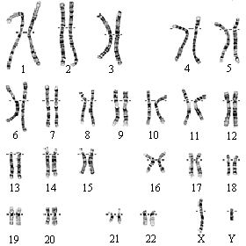
- #of chromosomes? 47 chromosomes Male or Female? Female Type of disorder? Down Syndrome due to the presence of Trisomy 21
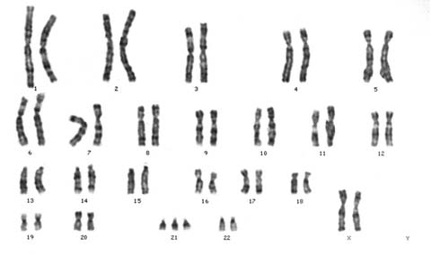

- #of chromosomes? 47chromosomes Male or Female? Female Type of disorder? Patau Syndrome due to trisomy 13
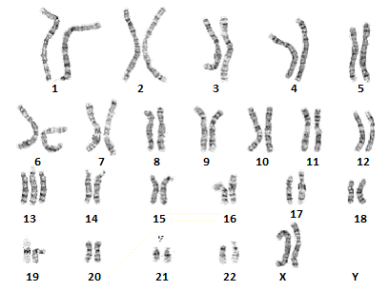
Part 2: Multifactorial Traits and Changes in Chromosomes Essay. (3 essays)
Essay I. Intelligence considered multifactorial; Please complete essay. 25pts Intelligence is considered a hot button topic when the debate over the influence of environment and heredity continues to be in the spotlight. Spotlight on Ethics page 235, 2nd edition, mentions a controversial publication The Bell Curve, that attempted to link IQ and race using test scores as an argument. How can you equate race( skin color comes in many hues) and IQ when humans have similar DNA. There is more variation within groups than between. Geneticists accused the authors of pseudoscience and ignoring the environmental factors that could play a huge role in test scores. State at least one environmental factor that you believe influences intelligence. For this essay, you can write between 150-200 words. If you are using other sources, please cite. Please write in your own words: https://psycnet.apa.org/doiLanding?doi=10.1037%2F0022-3514.69.5.797
Intelligence is a multifactorial factor determined by various factors environment and genetic being the key determinants (Silver & Nedelec, 2018). Nevertheless, environmental factors contribute significantly. A child’s intelligence quotient is greatly impacted by physical activities, place of residence, family income occupation of the parents, and education among other environmental-related factors. The essay, therefore, narrows down on how schooling as an environmental factor influences intelligence.
Education level is a key determinant of the intelligent quotient (IQ). The learning process usually starts from home and eventually to the learning institutions. Moreover, it is critical to note that children gain more insight once they step into schools. In the school setups, the children learn much from their instructors and their peers as well. According to Silver & Nedelec (2018), the learning process improves the intelligence capability of a child as they broaden their scope to view things differently. Research has indeed put it clear how schooling is an intellectual stimulant: increasing operational and functional intelligence. for instance, most children’s IQ decreases during school long holidays. Also, those children with no schooling history have relatively low intelligence quotient as compared to their educated counterparts. Therefore, it is practical to say that the level of education greatly determines an individual’s level of intelligence.

Essay II. Why is discrimination is considered a public health issue? Please complete the following essay located in the box below. 25pts We have mentioned some multifactorial traits such as hypertension, heart disease, depression etc . in Module 4. Stress is considered a risk factor. Previously, the American Medical Association issued a statement responding to how stress or chronic stress due to discrimination could be a contributing factor to many health issues, physical or mental. American Academy of Pediatrics recently posted information on the impact of discrimination on child and adolescent health. On this note, please view articles, videos below and in the learning center. See video from Harvard professor researcher who studies discrimination. Share your position on this particular subject. For this essay, you can write between 150-200 words. Please write in your own words. You can find other credible sources to support your thoughts. https://www.apa.org/pi/oema/resources/ethnicity-health/racism-stressand https://www.ncbi.nlm.nih.gov/pmc/articles/PMC4580597/ and https://pediatrics.aappublications.org/content/144/2/e20191765
Discrimination is a social stressor responsible for adverse health problems and a hindrance to the wellbeing of individuals (Sutter & Perrin, 2016). Many people have encountered discriminative measures that have left them to suffer various mental health diseases. As a fact, discrimination comes in all sorts of manner, arising from the basis of sex, gender, ethnic group, sexual orientation, nationality, and more importantly, the health condition of an individual. For example, the current United States racism issue has posed much of health impacts on the inhabitants. Therefore, it is true to say that all these retrogressive discriminatory measures are the stress pathways leading to physical health problems such as obesity, cardiovascular disease, and local or systemic infections.
Stress associated with discrimination poses a lot of risk to people. Sutter & Perrin (2016), suggest that chronic stress resulting from discrimination weakens the people’s immune system making them susceptible to contract most of the contagious diseases. Nonetheless, we can overcome these menaces by avoiding such punitive and discriminatory measure and restore better living standards.

Essay III. Explore how changes in chromosome number shape policies in two different countries. Complete the following essay located in the box below. 25pts
Please read the article below. Compare and contrast children diagnosed with Down Syndrome in Iceland and children diagnosed with Down syndrome in the United States: to view article click here Down's syndrome or copy link: https://www.cbsnews.com/news/down-syndrome-iceland/
For this essay, you can write between 150-200 words. If you use outside sources, please cite. Please write in your own words.
One of the differences between children born with Down syndrome in Iceland and in the United States is based on the population of the victims. It is evident that Iceland has fewer numbers of children living with Down syndrome unlike in the United States. For instance, the average numbers of children in Iceland who are born with Down syndrome are one or two yearly while the number in the US is quite higher since it is estimated at 6000 babies yearly. It means that one out of the 700 babies born in US every year is diagnosed with Down syndrome. On the other hand, children born with Down syndrome in Iceland and those in the United States are similar in terms of developmental issues. For instance, all of these children experiences developmental issues that emerge as a result of genetic disorder. An observable characteristic on these children is that that have facial such as small head or even flattened face.

References
Silver, I. A., & Nedelec, J. L. (2018). The moderating effects of intelligence: An examination of how IQ influences the association between environmental factors and antisocial behavior. Journal of Criminal Justice, 54, 62-75.
Sutter, M., & Perrin, P. B. (2016). Discrimination, mental health, and suicidal ideation among LGBTQ people of color. Journal of counseling psychology, 63(1), 98.

